Ecosystems 2: Population Dynamics and Animal Behavior
- What two things account for an increase in population size?

- What two things account for a decrease in population size?

- Define density-independent factors in your own words.

- Give at least 5 examples of density independent factors.

- Define density dependent factors in your own words.

- Give at least 5 examples of density dependent factors.

- Draw a graph showing population growth over time in an environment that has unlimited resources.

- Is the graph you drew showing exponential growth (j-curve) or logistic growth (s-curve)?

- Any thing or organism that regulates the size of a population is known as __________.
- a limiting measure
- a limiting factor
- carrying capacity
- biodiversity
- The largest number of individuals in a species that an environment can support long term
- carrying capacity
- emigration
- immigration
- population density
- If the carrying capacity of a predator decreases, what will happen to the carrying capacity of the prey?
- Will Increase
- Will Decrease
- Will stay the same
- Will fluctuate
- In a forest ecosystem, which of the following is the best example of a limiting factor for a rabbit population?
- Squirrel Population
- Sunlight
- Grass available
- When a population grows past the ecosystem's carrying capacity, what happens to the population?
- Continues to grow
- The population starts to die off to return to carrying capacity
- The population will go extinct due to lack of resources
- The population grows then finds a new carrying capacity

*Use the graph of Yellowstone data and table of Deer Island data on the next page to answer the following questions.*
- What is the carrying capacity for the wolves and for the deer on Deer Island? What correlation do you notice in the data for deer and wolf populations?

- What is the carrying capacity for the wolves and for the elk on Greater Yellowstone Area? What is the correlation between the two graphs in figure 2?

- Is there a causal relationship between size of the habitat and carrying capacity?

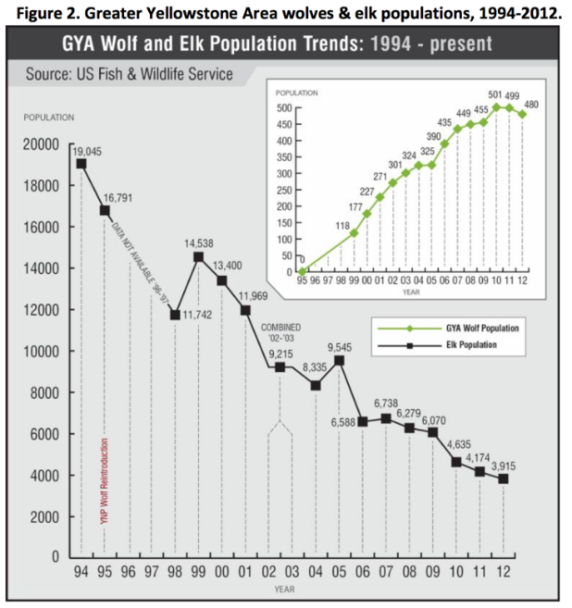
- What do you think the differences in diversity are between the two places?

- Yellowstone is much larger than the isolated Deer Island. Use the data in both figures to compare how scale or size of an area affects populations differently.
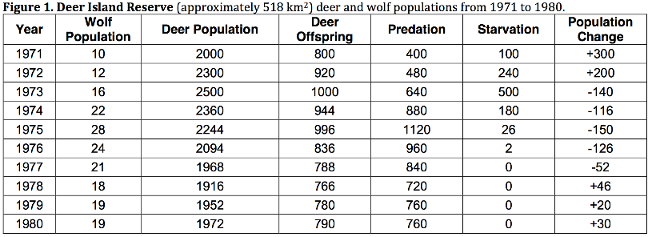

**********Read the following passage to answer questions 19-22.***********
Gray wolves (Canis lupus) were trapped in Canada and put in acclimation pens before being released. Fourteen wolves were introduced in 1995, and seventeen more in 1996.
Wolf #9, a female, was one of the wolves in the first shipment in 1995.
Soon after release, #9’s mate, #10, was shot and killed illegally outside the
park. Around the same time as #10’s death, #9 gave birth to eight pups.
The National Park Service team trapped #9 and her pups to put them back
in the acclimation pen to ensure their survival without the mate and held them throughout that first summer.
During the fall, they were all released. Male wolf #8, a disperser from another pack, was waiting outside the pen to become #9’s new mate. He frequently hung out around the acclimation pen all summer and was there the day of release. #8 accepted #9 as a mate, and the pups’ new adopted father (Smith et al. 1999). The pups wasted no time accepting #8, as they were seen nipping, barking, and pulling on his tail. The willingness to adopt offspring that have been sired by another male is rare in the mammal world (Smith and Ferguson 2005). One of those male pups, #21, actually adopted five pups that were not his and became a great alpha male himself. Thus, #9 put the Yellowstone wolf population back on the map.
- Describe the unique social behavior in the story above. List at least 1 and explain the advantages to the behavior (is there a survival, species, or reproductive reason)?

- What is the benefits and draw back to each type of behavior: solitary, cooperative group, and herd/flock. Answer in terms of reproductive success as well as continued survival of the individual or the species.

- Explain the group behavior of the wolves. Why is it beneficial? Detrimental? Why are there lone wolves? How does this affect the continuation of the species?

- Think of an example of mutualism that might be in the Yellowstone area. Commensalism? Parasitism?

