Ecosystems 2: Population Dynamics and Animal Behavior
- What two things account for an increase in population size?

Births and immigration

- What two things account for a decrease in population size?
Deaths and emigration

- Define density-independent factors in your own words.
Anything that limits population size and affects any population the same regardless of how big or small it is

- Give at least 5 examples of density independent factors.
Weather, climate, seasonal cycles, any natural disaster (tsunami, earthquake, hurricane, landslide, etc)

- Define density dependent factors in your own words.

Anything that limits population size AND affects larger populations more than small populations

- Give at least 5 examples of density dependent factors.
Competition over mates, competition for food, competition for territory, disease, predation, parasitism

- Draw a graph showing population growth over time in an environment that has unlimited resources.

You should have a graph that shows exponential growth- I cannot draw it in Word

- Is the graph you drew showing exponential growth (j-curve) or logistic growth (s-curve)?
J-curve – exponential
- Any thing or organism that regulates the size of a population is known as __________.
- a limiting measure
- a limiting factor
- carrying capacity
- biodiversity
- The largest number of individuals in a species that an environment can support long term
- carrying capacity
- emigration
- immigration
- population density
- If the carrying capacity of a predator decreases, what will happen to the carrying capacity of the prey?
- Will Increase
- Will Decrease
- Will stay the same
- Will fluctuate
- In a forest ecosystem, which of the following is the best example of a limiting factor for a rabbit population?
- Squirrel Population
- Sunlight
- Grass available
- When a population grows past the ecosystem's carrying capacity, what happens to the population?
- Continues to grow
- The population starts to die off to return to carrying capacity
- The population will go extinct due to lack of resources
- The population grows then finds a new carrying capacity

*Use the graph of Yellowstone data and table of Deer Island data on the next page to answer the following questions.*
- What is the carrying capacity for the wolves and for the deer on Deer Island? What correlation do you notice in the data for deer and wolf populations?
Wolves- approximately 20 Deer- approximately 1950
- What is the carrying capacity for the wolves and for the elk on Greater Yellowstone Area? What is the correlation between the two graphs in figure 2?
Wolves- approx. 460 elk approx. 4000 There is a correlation between wolf population size and deer population size. When wolf population increases, deer population decreases as a result of predation
- Is there a causal relationship between size of the habitat and carrying capacity?
Yes, increases habitat size directly increases carrying capacity as you can see in your answers to #14 and #15
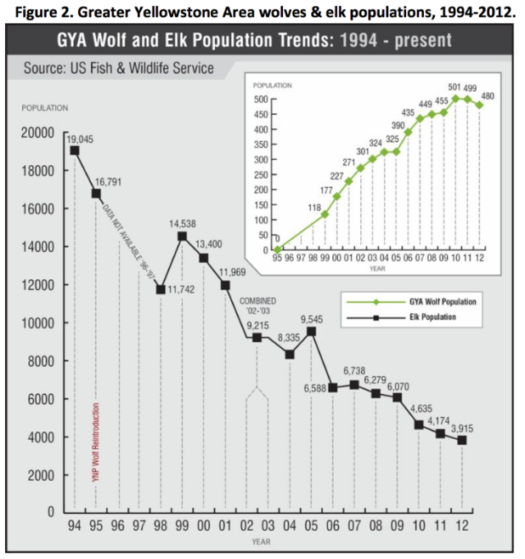
- What do you think the differences in diversity are between the two places?
Yellowstone has more diversity. It is larger, it is not on a island. The island is isolated so new populations cannot migrate.
- Yellowstone is much larger than the isolated Deer Island. Use the data in both figures to compare how scale or size of an area affects populations differently.
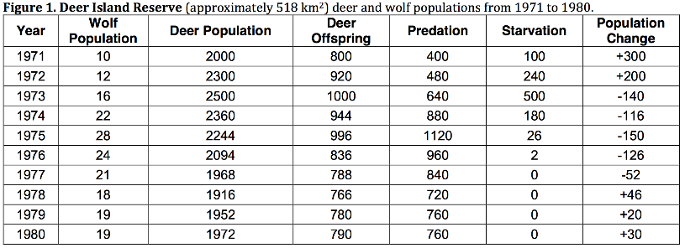

**********Read the following passage to answer questions 19-22.***********
Gray wolves (Canis lupus) were trapped in Canada and put in acclimation pens before being released. Fourteen wolves were introduced in 1995, and seventeen more in 1996.
Wolf #9, a female, was one of the wolves in the first shipment in 1995.
Soon after release, #9’s mate, #10, was shot and killed illegally outside the
park. Around the same time as #10’s death, #9 gave birth to eight pups.
The National Park Service team trapped #9 and her pups to put them back
in the acclimation pen to ensure their survival without the mate and held them throughout that first summer.
During the fall, they were all released. Male wolf #8, a disperser from another pack, was waiting outside the pen to become #9’s new mate. He frequently hung out around the acclimation pen all summer and was there the day of release. #8 accepted #9 as a mate, and the pups’ new adopted father (Smith et al. 1999). The pups wasted no time accepting #8, as they were seen nipping, barking, and pulling on his tail. The willingness to adopt offspring that have been sired by another male is rare in the mammal world (Smith and Ferguson 2005). One of those male pups, #21, actually adopted five pups that were not his and became a great alpha male himself. Thus, #9 put the Yellowstone wolf population back on the map.
- Describe the unique social behavior in the story above. List at least 1 and explain the advantages to the behavior (is there a survival, species, or reproductive reason)?
Altruism- It is unique for a wolf to father pups that are not his.. this is a disadvantage at first, because they need to be fed and protected by #8, BUT all the wolves, including #8 were more likely to survive living together rather than individually. Also, #8 increased his reproductive success by finding a mate.

- What is the benefits and draw back to each type of behavior: solitary, cooperative group, and herd/flock. Answer in terms of reproductive success as well as continued survival of the individual or the species.
Solitary: less competition for food, but less likely to survive
Cooperative Group: Greater protection from predators, more likely to have reproductive success, young are more protected, but also greater likelihood for contracting disease, and more competition because resources are shared
Herd/flock: Less likely to be eaten by predator because there are so many organisms in one place, but also being in a large group makes you more visible to predators. It is easier to forage for food and mates are readily available.

- Explain the group behavior of the wolves. Why is it beneficial? Detrimental? Why are there lone wolves? How does this affect the continuation of the species?
This has already been explained quiet a bit above. Wolves are more likely to get food and take down competition from other species by living in packs. It allows them to care for their young. It leads to greater likelihood of reproductive success. Each wolf takes on a specific role that ensures the overall function and survival of the pack. The downside is that the wolves have to share their food, and disease will spread more easily. There are lone wolves because wolves will be forced to leave the pack if they do not fall in line of the hierarchy. For example, a young wolf might attempt to be dominant and receive a lot of aggression from the older dominant wolves. An alpha male that is old or sick may leave its pack because it cannot lead anymore. This actually is good for the continuation of the species. The old wolf has already reproduced and is not likely to again. Since he is not going to reproduce anymore wolves, and he cannot keep up with the pack, he would only put the rest of the wolves in danger and require their time and resources to keep him alive and fed. The whole pack is better off if the old sick wolf leaves.
- Think of an example of mutualism that might be in the Yellowstone area. Commensalism? Parasitism?

