Group Behavior: Make a Meme Assignment
Directions:
- Choose an animal
- Once you have chosen an animal (group), research the species' lifestyle (habitat, diet, etc.), group behaviors (herding, hunting, communication, hierarchies, courtship, etc.), and other interesting facts.
- Complete graphic organizer attached to this document
- Create a meme illustrating your animals behavior (solitary, flock, herd, pack, etc)
- You can create the meme digitally or you can do it on paper
- Must include an image of your animal, with a phrase or sentences relating to this animals behavior and the pros and cons
To choose an animal:
- The link below will take you to a list of animals you can choose from. The column on the far right tells you what type of social behavior they exhibit.
- http://www.enchantedlearning.com/subjects/animals/Animalbabies.shtml
To research your animal:
- You can do a simple google search, or you can use the following links that I have specifically found for this project. Remember you don’t have to write a 5 page paper about your animal, you’re just getting enough information to complete the graphic organizer
- http://animals.nationalgeographic.com/animals/facts/
http://a-z-animals.com/animals/
http://enature.com/home/
http://animals.sandiegozoo.org/

Examples:
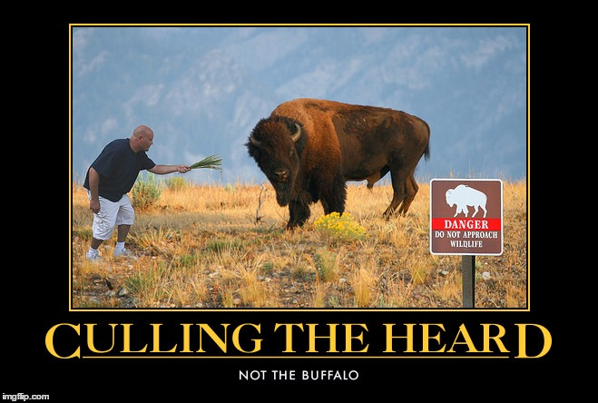
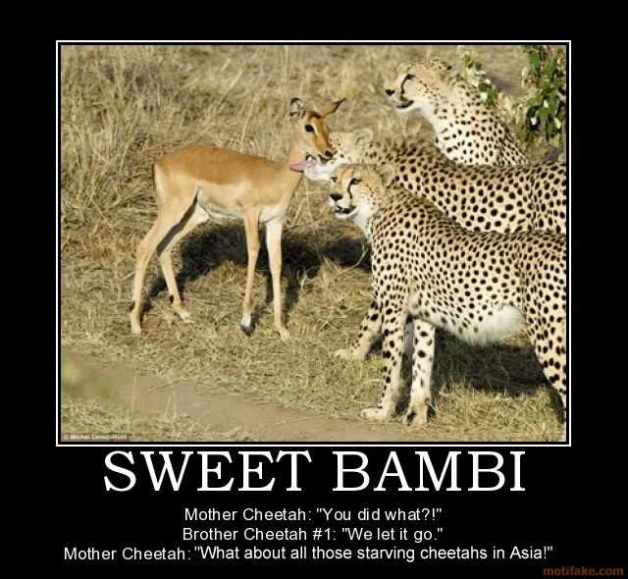

Name(s)___________________________________________________________________________ Hour______ Date_____________________

Animal Group Behavior Webquest – Notes and Brainstorming
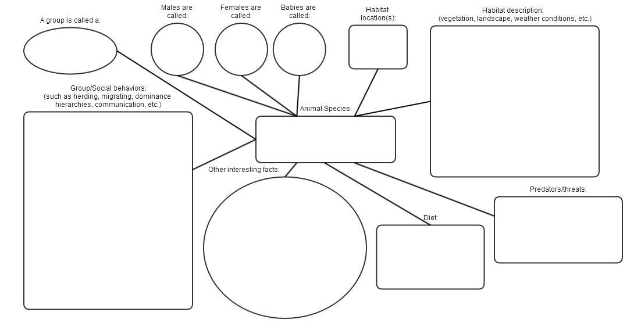

Meme ideas:

