Plant Biology

SYLLABUS AND EXPECTATIONS

Teacher: breanne willard ROOM #: 102

Phone #: 253.571.6102 OFFFICE HOURS: Mon-Fri 7:00am-3:30pm

EMAIL: bwillar@tacoma.k12.wa.us WEBSITE: http://willardbiology.weebly.com

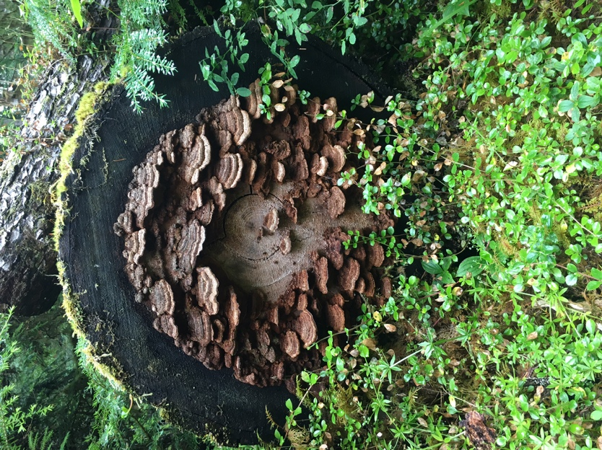
- COURSE DESCRIPTION
Plant Biology is a full-year course exploring our physical world through scientific inquiry, with an emphasis on plant systems and horticulture. Topics include photosynthesis, genetics, biological matter & organization, plant and soil systems, and plant growth. Our studies will revolve around hands-on learning experiences that will put you in the role of botanists, and much of our time will be spent in the greenhouse. Your performance in this class will be measured by how well you can solve problems, demonstrate your understanding of scientific concepts, and fulfill your role in our greenhouse. For this reason, your active participation and productivity in class are the most significant commitments you can make to yourself and me during this course. I look forward to our joint exploration of the living world around us!

- STUDENT OUTCOMES
Unit | Description
Plant Cells and Organelles | Membranes, osmosis, transpiration, photosynthesis, respiration
Genetics | Genetic inheritance in agricultural plants
Mitosis and Meiosis | Mitosis, meiosis, and pollen tubes
Plant Propagation | Sexual and asexual reproduction
Plant Growth and Development | Plant life cycle, factors affecting plant growth, fertilizer, and soil
Integrated Pest Management | Management of insects and disease
Biotechnology | GMOs and medicinal use of plants
Plant Propagation and Development | Propagate, culture, and harvest plants
Plant Physiology, Growth, and Development | Prepare and implement a plant management plan that addresses the influence of environmental factors, nutrients, and soil

- MATERIALS

Required Materials
- Composition Notebook
- Pens (blue or black ink)
- Pencil
- Highlighter
Recommended Materials
- Ruler
- Scissors
- Coloring Utensils
- Lab Coat (can be purchased through school for approximately $15-20)

- CLASSROOM NORMS

- Respect your peers, ALWAYS. This classroom will be a safe and respectful learning environment for every student.
- Respect Equipment and Facilities: Clean up properly (Each student will be graded down for lab assignments for improper or lack of cleaning). A person willfully endangering the safety of others such as inappropriate use of machinery or a person vandalizing the greenhouse facilities, grounds, or classroom will be dropped from the class and will be required to pay for damages.
- Arrive on Time: It is your responsibility to arrive on time and enter in a quite manner. Report to your chair and do your daily entry task.
- Be prepared: At the start of each class, have a pen/pencil, journal, and paper ready to complete your daily “Entry Task”.
- Follow School Rules: No headgear (hats, rags, nets, hoods, etc.), No CD players, cell phones, digital music players, or video games are permitted during school hours. Hall passes will be required to leave during class and will be used sparingly. I reserve the right to confiscate cell phones, music players, and video games which are being used in class without permission.
- Dismissal: Students will be dismissed by the instructor, not by the bell. Classes will sometimes go late for various reasons. The last period of the day needs to put your chairs up on tables. Stay in seat until dismissed in classroom, or if in greenhouse, wait inside the greenhouse.

- ATTENDANCE
So much of what we do in biology is through hands-on work in class, so it is essential that you’re present in order to master the material. Due to the nature of activities completed in class, it is never guaranteed that missed assignments and labs can be made up if you are not present for them.
- TARDY POLICY
You are given two ‘free’ tardies per semester. Daily participation points will be lost for each additional tardy AND: 4 tardies will result in a teacher conference and behavioral contract, 8 tardies will result in office referral, and 10+ tardies may result in being dropped from the class.
- EXCUSED ABSENCES
You are responsible for collecting and making up all missed work. Assignments can be found on the class website, and in the assignments folder located in the classroom. Please do not ask for missed assignments during class. Your make-up work must be completed within 3 days of your return to school (unless other arrangements are made with the teacher) including labs, quizzes, and tests. Work assigned prior to your absence must be turned in immediately upon your return.
- UNEXCUSED ABSENSES
Daily participation points will be lost for each unexcused absence. Labs cannot be made up. Assignments turned in late due to an unexcused absence will receive partial credit.

- ASSESSMENT & GRADING SCALE
Grades for this course are weighted. Performance assessments (tests) are worth 65% of the total grade. Assignments are worth 10%. Labs are worth 10%. Homework is worth 10%. Final Exam is worth 5%.

A = 100-94%
A- = 93.9-90%
B+ = 89.9-87%
B = 86.9-84%
B- = 83.9-80%
C+ = 79.9-77%
C = 76.9-74%
C- = 73.9-70%
D+ = 69.9-66%
D = 65-60%
E = 59.9% and below

- ACADEMIC INTERVENTION
Any student who has not met a standard (demonstrated conceptual understanding) on his/her first attempt, AND has an overall grade below a ‘C’ will be required to complete additional learning work, academic intervention, and re-testing which generally runs from 2:15-2:45 (check the weekly schedule/updates on the classroom website for specific dates and times). During this time, students will have large or small group tutorials and/or time to work on the assessment/re-test. Individual help can be scheduled outside academic intervention. Academic Intervention is MANDATORY regardless of extra curricular activities.

- ASSIGNMENT BREAKDOWN
There are 4 types of daily assignments: written assignments, activities, note [readings/video/lecture], and labs. Students are required to maintain a Lab Journal containing all assignments. In addition, students will complete assessments periodically (which may be quizzes, tests, projects, or other performance assessments).
- LABORATORY: Students will be in a laboratory setting approximately once each week. Labs will include extensive pre-laboratory homework, the completion of the labs in class, assessment, and post-laboratory work (data analysis, book work & formal conclusions).
- QUIZZES will be both announced and unannounced. (The class following a lab or a reading assignment is a good time to expect a quiz!).
- STANDARD ASSESSMENTS (often thought of as exams but also include papers, projects, oral exams, etc) used to show proficiency within each of the targeted areas (the standards).

- HOMEWORK
Homework is an extremely important aspect of this course, and serves two purposes: to expose students to new material so that they are ready to do hands-on activities when they arrive in class, or to give students an opportunity to practice and assess their own skills/knowledge. If homework is not completed, students may be disqualified from participating in classroom activities until it is complete, as they cannot move deeper into coursework on a given topic until underlying material is grasped. Homework will commonly be analysis questions from classroom activities, pre-labs to prepare for the next day, test study guides, and videos to introduce new concepts. Expect to have homework 3 times a week.

- LEADERSHIP
A final component of this course is leadership. This is a CTE (career and technical education) course, meaning that in addition to providing science knowledge, it is meant to provide students with opportunities and skills to enter the workforce. Each student will be required to submit evidence of leadership activities. This could include participation in clubs, volunteering, after-school enrichment programs, working collaboratively in class, or helping other students. This component will be worth 100 points.

- ACADEMIC INTEGRITY
Plagiarism is using someone else’s work or ideas without their permission, without their knowledge, or without giving them credit. Cheating is getting or giving someone else answers. During many in-class assignments you will work with other students but are responsible for recording your own ideas and work. If you do research for an assignment, you must put what you learn into your own words. All students who are caught cheating or plagiarizing will receive a zero on that assignment.

- LATE ASSIGNMENTS
Homework and other assignments that are turned in late will be eligible for partial credit. Some assignments will not be accepted late, as deemed by the teacher. Exceptions will be made for excused absences (please read attendance policy on the previous page). The most important thing is that you communicate with the teacher before assignments are passed due, so that in the case of exceptional circumstances, alternative arrangements can be made.

- ELECTRONICS
Use of cell phones, iPods, and other electronic devices will not be permitted in class, except when instructed to do so. This is a strict policy. The first violation: verbal warning. The second violation: phone will be confiscated and you may pick it up at the end of class. The third violation: phone will be confiscated and you may pick it up at the end of the school day. The fourth violation: phone will be confiscated, and will require parent pick up.

- FOOD & BEVERAGES
Water that is contained in a sealable bottle is permitted in class. Food and other beverages will need to be stored in backpacks or in the hall. This is a safety issue, as we will be experimenting with live bacteria, chemicals, and other potentially harmful agents in this class. If you are eating in class, you will be asked to dispose of your food. If this becomes a chronic problem, an office referral may be issued.

- USE OF GREENHOUSE
We will be spending time in the greenhouse throughout the year. Please note that the temperature is kept relatively warm at all times, and we will be working with soil and other materials that can be messy. Students need to wear closed-toed shoes, and have an appropriate shirt under any sweaters/hoodies, as they may get hot. Aprons are available, and students will be told at least 1 day in advance when class will be in the greenhouse.

Aknowledgement of syllabus

Please make sure you have read and understand your student’s expectations, commitments, and syllabus, the Tacoma Public Schools Student Safety Expectations, and the parent letter.

List any concerns or comments below and sign the bottom of this page. Please be sure to leave at least one phone number and/or email address where you can be reached during the time of your child’s class.

Daytime Phone Number: __________________________________

Specific issues, concerns, or comments about your child:

Students please confirm that you understand the following class guidelines by initialing next to each item.
- I understand that make up work is after school. _____
- I understand that attendance in class greatly affects grades _____
- I understand that there will be homework ____
- I understand there are no electronics used in class, & phones may be confiscated _____
I UNDERSTAND AND AGREE TO PERFORM TO & COMPLY WITH THE POLICIES STATED IN THIS SYLLABUS.

___________________________________ _________________________________________ ______________
Student Printed Name Student Signature Date

___________________________________ _________________________________________ ______________
Parent Printed Name Parent Signature Date

Sign and return by: Wednesday September 13, 2017

